MUHAMMAD AHMAD RAZA

467253

//HOME TASKS

//TASK 1

#include<iostream>

using namespace std;

int main() {

int num,i,r,sum,check;

sum=0;

check=0;

for(num=0;num<=50;num++)

{

if(num==0||num==1)

{

continue;

}

for(i=2;i<num;i++)

{

r=num%i;

if(r==0)

{

check++;

break;

}

}

if(check==0&&num!=1)

{

sum=sum+num;

}

check=0;

}

cout<<"The sum of prime numbers between 1 and 50 is "<<sum<<endl;

return 0;

}

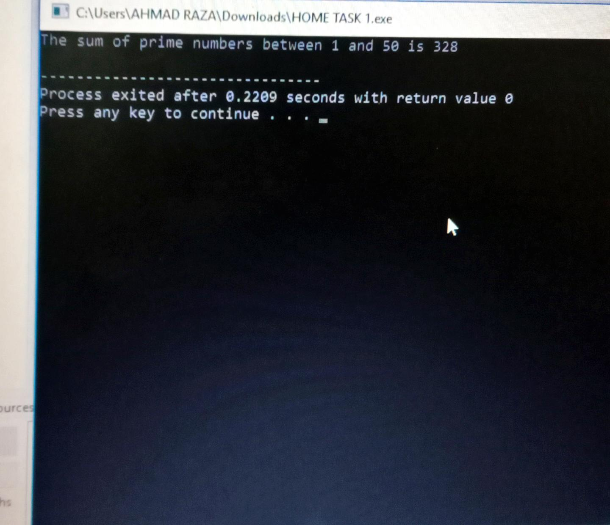

//TASK 2

#include<iostream>

using namespace std;

int main() {

for(int i=1;i<=5;i++)

{

for(int j=1;j<=5;j++)

{

if(j<=i)

{

cout<<j<<" ";

}

else

{

continue;

}

}

cout<<endl;

}

return 0;

}

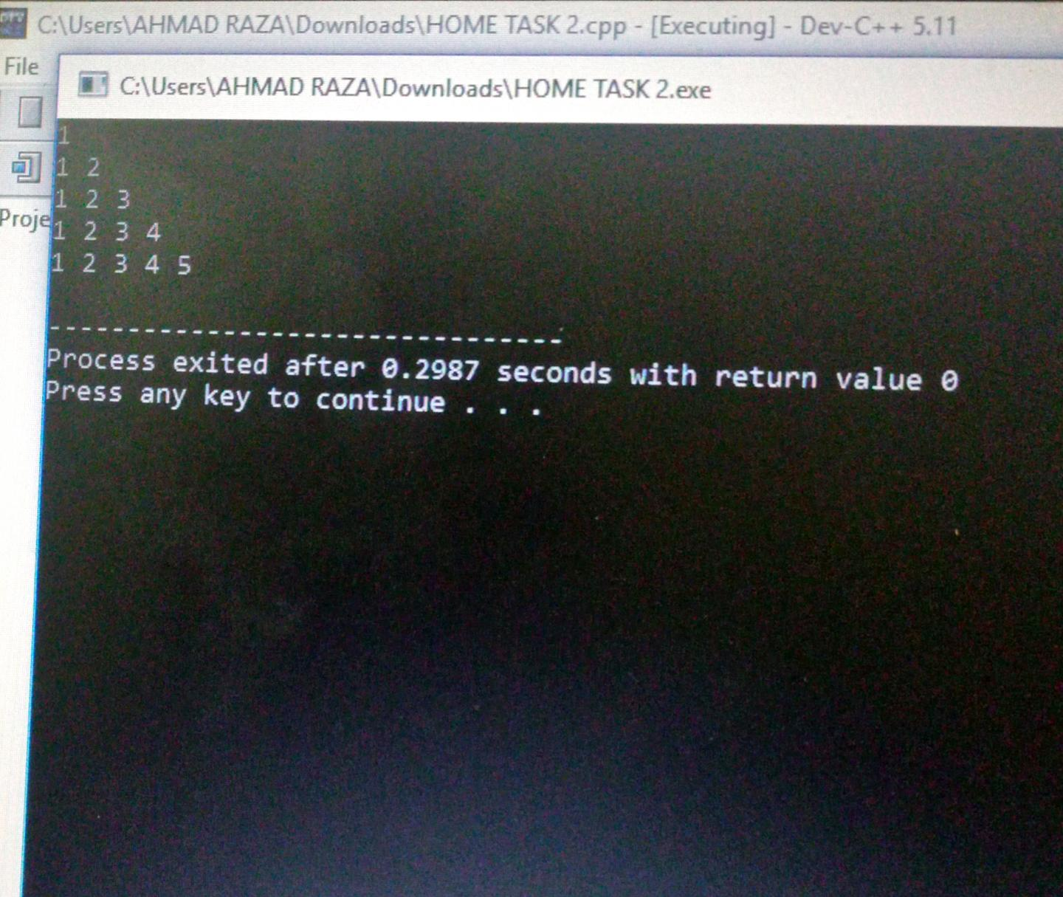

//TASK 3

#include<iostream>

using namespace std;

int main() {

for(int i=1;i<=4;i++)

{

if(i==1)

{

cout<<i<<endl;

continue;

}

else

{

for(int j=1;j<=6;j++)

{

for(int k=2;k<=6;k+=2)

{

if(k==j)

{

for(int l=1;l<=k;l++)

{

cout<<k<<" ";

}

}

else

{

continue;

}

cout<<endl;

}

}

cout<<endl;

}

return 0;

}

